December 2023 BANA 614



Parts Delivery

Direct Analytics

Presented by:

Denise Becerra, Emely Callejas, Ashley Cortez,

Robert Pimentel, Angelica Verduzco

Table of Contents

Description of the Business 3

Executive Summary 3

Case Background 5

Business Problem 5

Project Scope 5

Business Rules 5

ERD 6

Relational Data Model (1NF) 7

Normalization(2NF) 7

Queries 8

Query 1: (Denise) 8

Query 2: (Emely) 9

Query 3: (Ashley) 10

Query 4: (Robert) 11

Query 5: (Ashley) 12

Query 6: (Angelica) 13

Recommendations for the Business 14

Appendix 15

Delivery Receipt Example 15

Materials Invoice Example 16

Snapshot of Database Tables 17

## Description of the Business

Parts Delivery Direct (PDD) is a dispatch company that specializes in assisting with the delivery of automobile part shipments. They typically offer logistics services between customers and trucking companies to ensure that goods are delivered safely and on time. When organizations order automobile parts a booking is placed and is assigned to a respective supplier. Within each supplier, each driver needs to meet a minimum kilometer requirement for each trip. Driver efficiency is observed by comparing the actual trip time versus the planned trip time.

### 

## Executive Summary

Parts Delivery Direct is a trucking delivery company located in the Midwest of the United States where there are a variety of deliveries made such as auto parts and equipment. The trucking company’s mission is to deliver these parts in a timely manner at a competitive price. After reviewing and comparing planned (Estimated Time of Arrival) ETA and actual ETA the delivery times, we believe the times can be closer to planned ETA by better planning. By reducing delivery times, our company can better meet customer expectations with faster delivery times.

Our focus is recognizing the vital step of efficient planning in meeting delivery commitments. Parts Delivery Direct is committed to enhancing our operational efficiency. Through careful review of our dataset and comparing the planned ETAs versus the actual ETAs, we have identified room for improvement in this area. By refining our deilvery processes, we aim to bring actual delivery times closer to planned ETAs to optimize transportation for efficient deliveries

Our strategy method is to focus on optimizing planning procedures to minimize delivery times. We will analyze and fine-tune the logistics involved in our trucking operations in order to achieve a significant reduction in delivery times. This not only enhances our ability to meet customer expectations promptly but also positions Parts Delivery Direct as a reliable and agile partner in the transportation industry.

At the heart of our mission is a commitment to meet customer satisfaction. We understand that in today's trucking industry, timely deliveries are important to customers. We hope by streamlining our operations and implementing efficient planning strategies by using our dataset, we aim to provide customers with better delivery times to enhance their satisfaction and loyalty to our company.

In today’s competitive trucking market where efficiency is a key differentiator, Parts Delivery Direct’s main goal is to improve these delivery times to gain a competitive edge against other competitors. We are aiming to consistently deliver on time and optimize our operational delivery processes and by doing so, we position ourselves as a preferred choice for businesses searching for reliable and efficient transportation services.

Parts Delivery Direct is dedicated to meet the expectations of our clients. Our commitment to optimizing delivery times through improved planning is a demonstration of our customer-centric approach. As we begin to improve our operational efficiency, we invite our business partners and clients to join us in setting the evolving standards of reliability in the trucking industry.

## Case Background

* Business Location: 12341 Harvey Street, Boise, Idaho, 17234
* Activities: Trucking Delivery Services
* Contact Person: Emely Callejas

## Business Problem

* Parts Delivery Direct currently facilitates deliveries by dispatching various drivers from suppliers they partner with. The company would like to analyze current operational processes and driver bandwidth in order to optimize delivery times by efficiently dispatching drivers.

## Project Scope

* PDD Analytics Team (5 members) - responsible for analyzing the dataset in its entirety (the dataset includes records from 2022 - 2023).
* Objectives: While reviewing the dataset, the analytics team should identify opportunities for improvement that would aid in optimizing delivery times and overall company efficiency.

## Business Rules

* Each CUSTOMER can place one or many BOOKINGS
* Each BOOKING is placed by one and only one CUSTOMER
* Each DRIVER can be assigned one or many BOOKINGS
* Each BOOKING is assigned one and only one DRIVER
* Each DRIVER is employed by one and only one SUPPLIER
* Each SUPPLIER hires one or many DRIVERS
* Each VEHICLE is owned by one and only one SUPPLIER
* Each SUPPLIER owns one or many VEHICLES
* Each BOOKING is completed with one and only one VEHICLE
* Each VEHICLE can complete one or many BOOKINGS

## 

## ERD

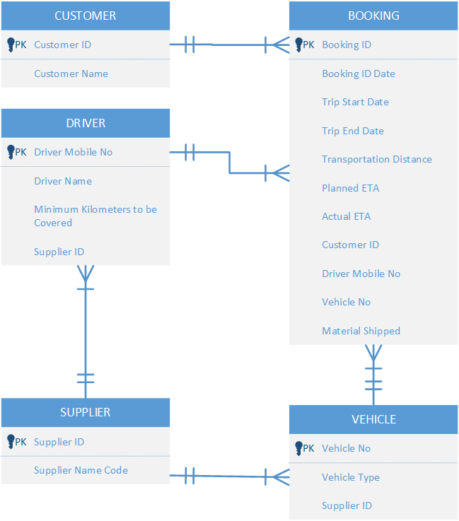

## Relational Data Model (1NF)

## 

## 

## 

## Normalization(2NF)

## 

## 

## 

## 

## 

## 

## 

## 

## 

## 

## 

## 

## 

## 

## Queries

### Query 1: (Denise)

What percent of drivers have an unknown (999) supplier ID?

* Display the percentage of drivers that have ‘999’ as their supplier ID

SELECT (COUNT(Driver_Name) * 100.0 / (SELECT COUNT(Driver_Name) FROM Driver)) AS PercentDriversWith999

FROM Driver

WHERE SupplierID = "999";

**Conclusion:**

14% of the drivers are identified with an unknown supplier ID(coded as 999). By knowing what percent of the drivers with unknown supplier IDs, PDD can closely track the updates of their records to ensure accurate data quality and integrity as well as the operational efficiency which is crucial to logistics and fleet management.

**Recommendation:**

Identify the potential gaps in onboarding and documentation processes that lead to selecting an unknown supplier ID. Addressing this issue will lead to a smoother operational efficiency and reduce likelihood of errors.



### Query 2: (Emely)

What is the average Transportation distance that is above the minimum 250 km? What is the maximum Planned ETA?

* Since the minimum km to be covered in a day is 250, we wanted to show the average distance in km equal to or greater than to 250 km
* Displays the average of the of each Supplier and Driver Number
* Displays Maximum Planned ETA

SELECT D.SupplierID, D.Driver_MobileNo, MAX(B.Planned_ETA) AS MAXPLANNEDETA,

AVG(B.Transportation_Distance) AS AVGDistanceinKM

FROM Booking B, Driver D

WHERE D.Driver_MobileNo = B.Driver_MobileNo

AND B.Transportation_Distance >= 250

GROUP BY D.Driver_MobileNo, D.SupplierID

**Recommendation:**

The average distance in KM was around 1175 KM. Since the minimum distance to be traveled is 250 KM, the Suppliers and Drivers should try to aim for more than 1175 KM traveled to be efficient.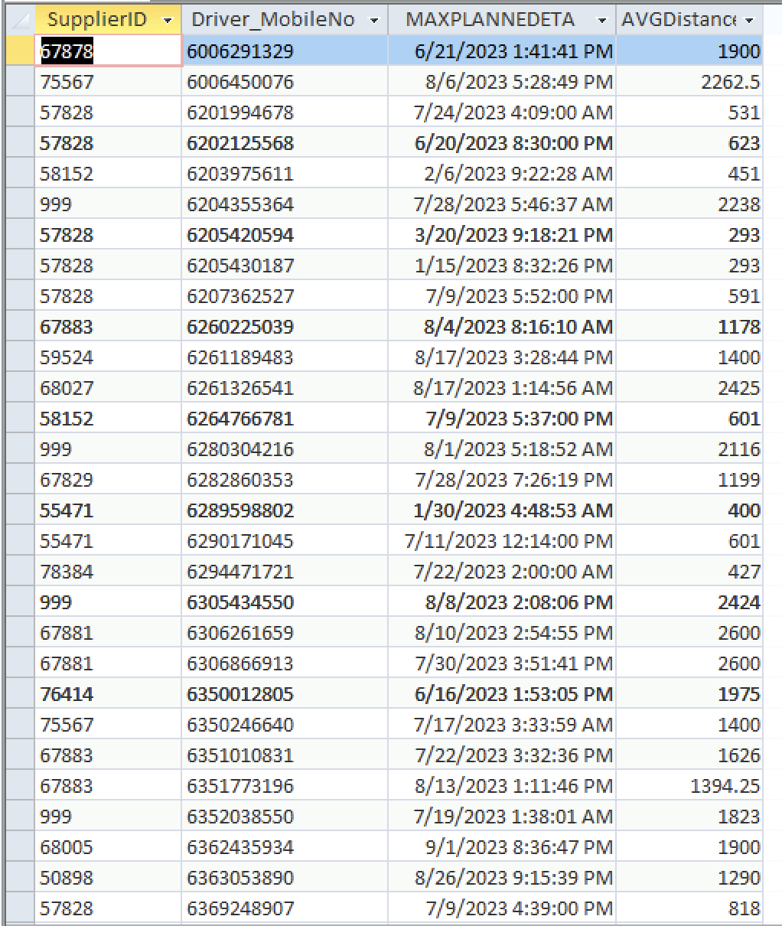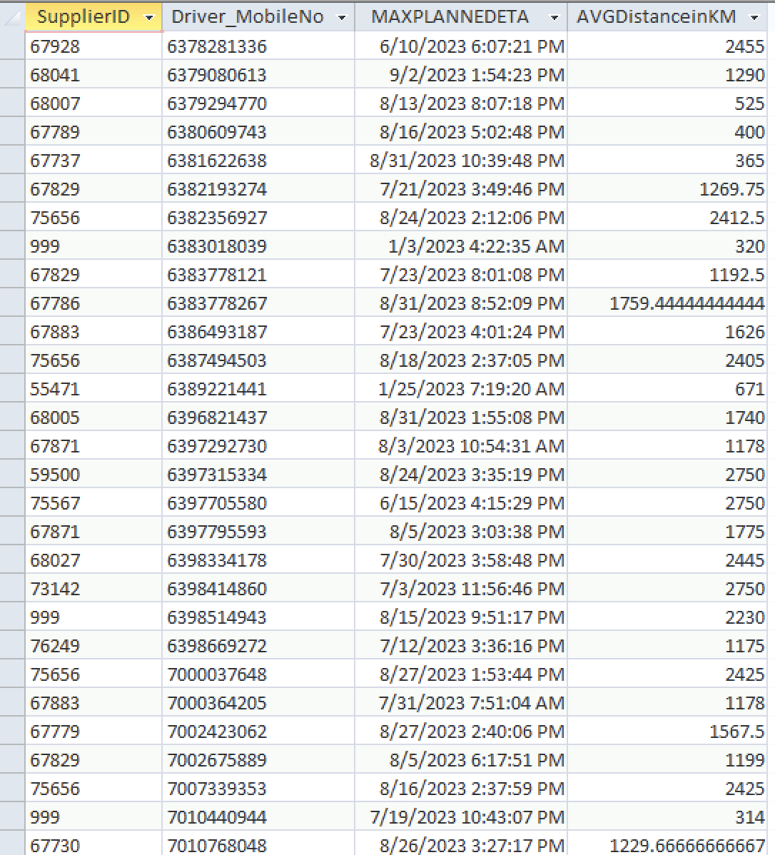

### Query 3: (Ashley)

What is the bandwidth of each supplier? Which supplier has the longest average trip duration?

* Display the Supplier ID, Supplier Name Code, Count of Drivers for each Supplier, and the average trip time for each Supplier

SELECT DISTINCT B.SupplierID, S.Supplier_Name_Code, COUNT (D.Driver_MobileNo) AS CountDrivers , AVG(Trip_Elapsed_Time) AS AvgTripTime

FROM Booking B, Supplier S, Driver D

WHERE B.SupplierID=S.SupplierID

AND S.SupplierID = D.SupplierID

AND B.Driver_MobileNo = D.Driver_MobileNo

GROUP BY B.SupplierID, Supplier_Name_Code

ORDER BY AVG(Trip_Elapsed_Time) DESC

**Conclusion:**

Overall Average Count of Drivers is 14 drivers per each supplier. Suppliers with less than 13 drivers have the longest Average Trip Time at 8.5 days per trip.

Suppliers with 13+ Drivers have an Average Trip time of 5.6 days per trip.

**Recommendation:**

Cease partnership with Suppliers that have less than 13 drivers to optimize average delivery times.

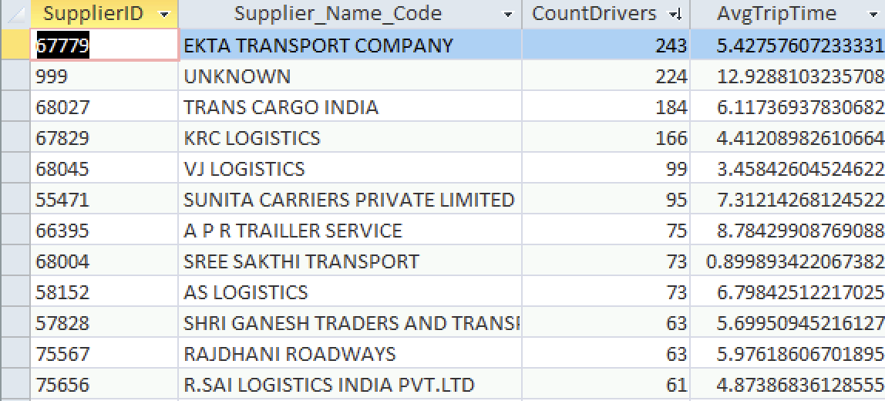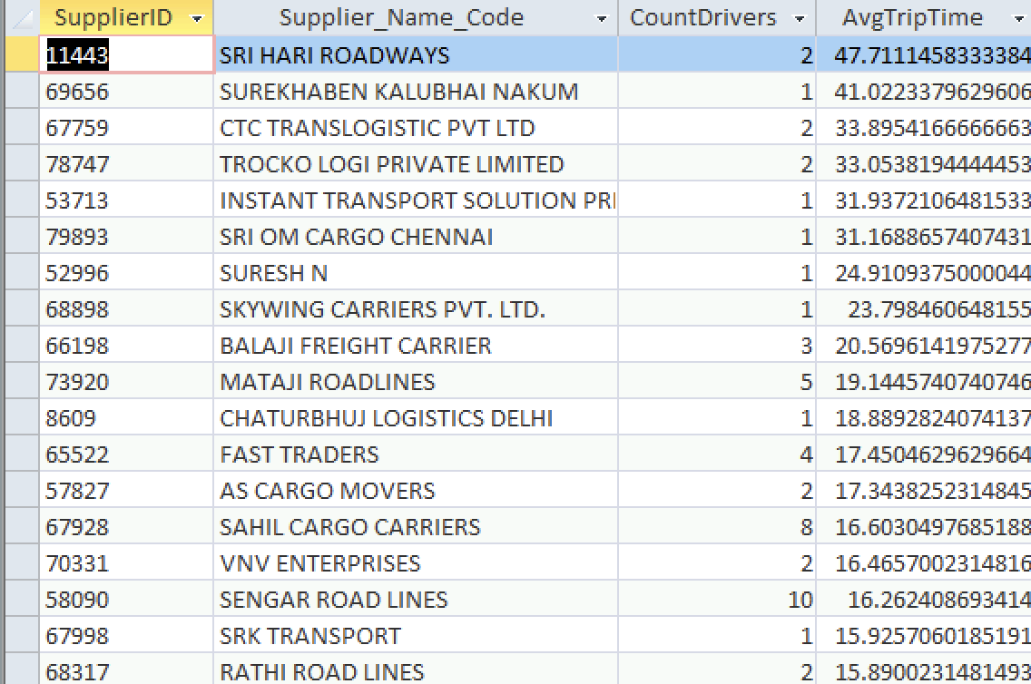

### Query 4: (Robert)

What percentage of Customers receive their booking by its planned ETA?

* Display CustomerID, Customer Name, and the percentage of bookings that were received on time (by its planned ETA)

SELECT Customer.CustomerID, Customer.Customer_Name,

IIf(Count(Booking.BookingID) = 0, 0, (Sum(IIf(Booking.Actual_ETA <= Booking.Planned_ETA, 1, 0)) / Count(Booking.BookingID)) * 100) AS PercentageOnTime

FROM Customer

INNER JOIN Booking ON Customer.CustomerID = Booking.CustomerID

GROUP BY Customer.CustomerID, Customer.Customer_Name;

**Conclusion:**

From the database, it is showing that 4 out of the 29 customers who put in an order receive an on time delivery rate of 90% or higher. That means 86% of the rest of the clientele do not receive their shipments on time. The implication here is that there are bottlenecks when the shipment leaves the facility and there needs to be an in-depth analysis into what causes these delays whether it be internal factors or external.

**Recommendation:**

The company needs to analyze what is bottlenecking its operations when it comes to delivery times. The Company should look into areas such as route projections, vehicle operations, driver training, and so forth in order to optimize its effectiveness when delivering its products to customers on time. 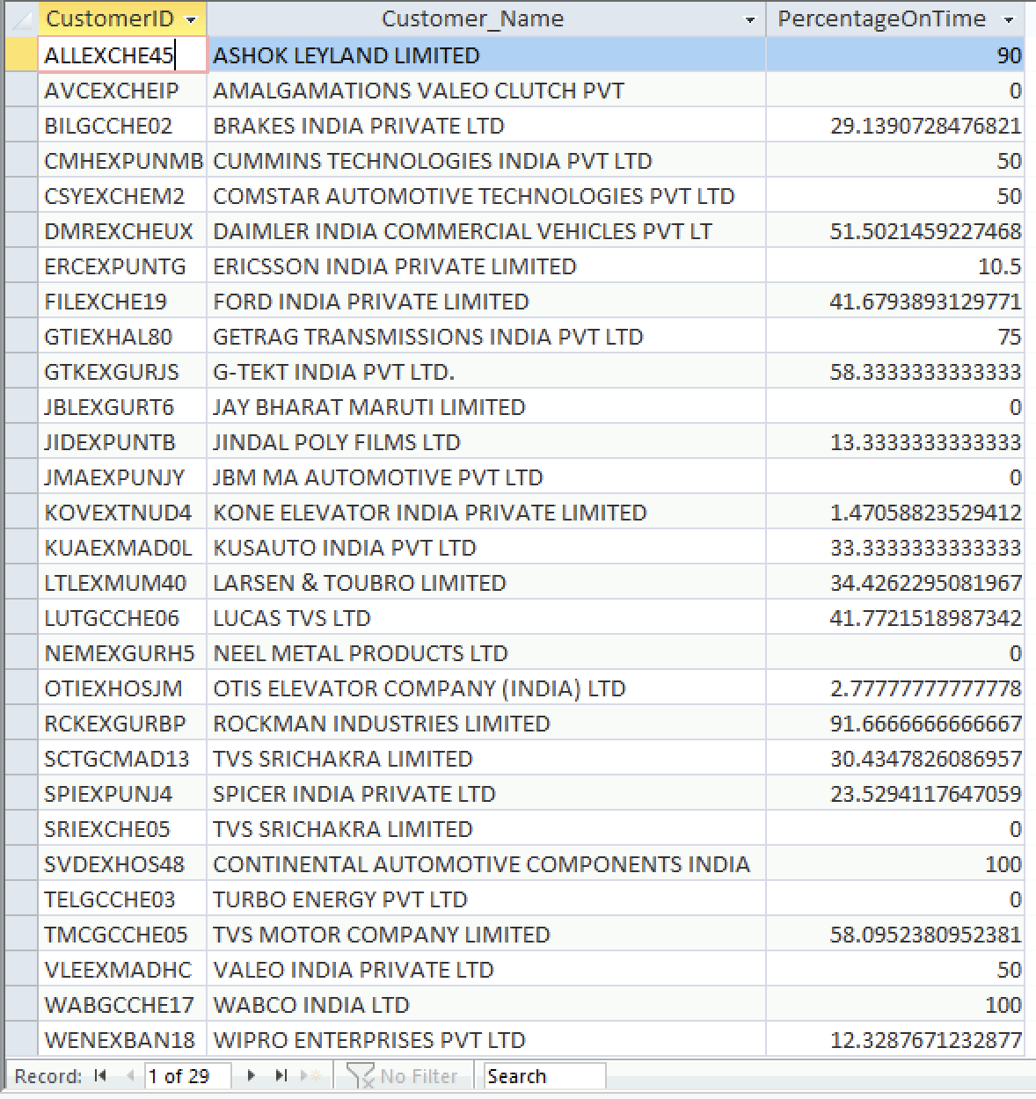

### Query 5: (Ashley)

How many bookings had a Trip_Elapsed_Time that was at least 2x greater than the average booking Trip_Elapsed_Time of each Customer? Is there a relationship between a longer trip time and Material Shipped?

* Display Customer ID, Booking ID, Trip Elapsed Time, Average Elapsed Time for each customer, and Material Shipped

SELECT OutsideT.customerID, BookingID, Trip_Elapsed_Time,

(SELECT AVG(Trip_Elapsed_Time)

FROM Booking as B

GROUP BY B.customerID

HAVING B.customerID = OutsideT.customerID) as AvgElapsedTime, MaterialShipped

FROM Booking AS OutsideT

WHERE Trip_Elapsed_Time >=

2*(SELECT AVG(Trip_Elapsed_Time)

FROM Booking as B

GROUP BY B.customerID

HAVING B.customerID = OutsideT.customerID)

ORDER BY Trip_Elapsed_Time DESC

**Conclusion:**

There were 200 bookings that had a Trip_Elapsed_Time that was at least 2x greater than the average booking Trip_Elapsed_Time for each customer.

There was no clear relationship between Material Shipped and a longer than average trip elapsed time. However, approximately 42% of the bookings in the query were marked as shipping a generic “AUTO PARTS” under Material Shipped.

**Recommendation:**

PDD should incorporate Material Shipped size and/or weight information in their company data. These details could contribute to a longer trip time if materials are larger or heavier than average.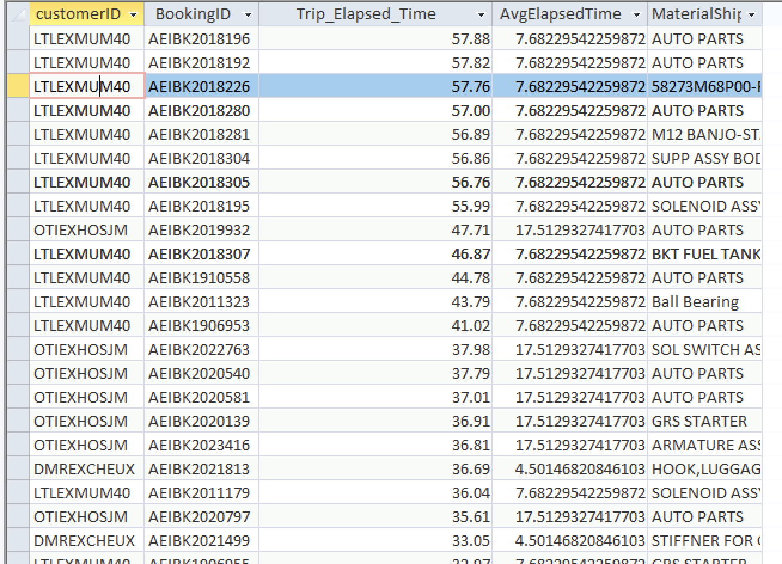

### Query 6: (Angelica)

How does the average delay in arrival times vary among suppliers? Are there suppliers consistently experiencing higher or lower delays in their trip arrivals?

* Display Supplier ID, Supplier Name Code, and the Average Delay in Minutes (by using Actual ETA - Planned ETA)

SELECT s.SupplierID, s.Supplier_Name_Code,

AVG((b.actual_eta - b.Planned_ETA) * 24 * 60) AS avg_delay_minutes

FROM Supplier AS s

INNER JOIN Booking AS b ON s.SupplierID = b.SupplierID

WHERE b.Planned_ETA IS NOT NULL

AND b.actual_eta IS NOT NULL

GROUP BY s.SupplierID, s.Supplier_Name_Code

ORDER BY s.SupplierID;

**Conclusion:**

Supplier TAMIL TRANSPORT, and SUREKHABEN KALUBHAI NAKUM demonstrate higher average delays compared to others, this would imply potential issues in their operations.

**Recommendation:**

Analyze common routes among suppliers that experience higher delays to attempt to identify potential issues and alter the routes for better efficiency.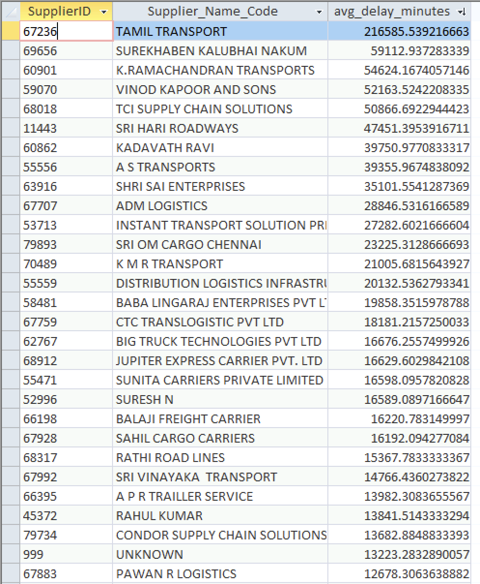

## Recommendations for the Business

To enhance the operational efficiency and ensure a timely delivery of automobile parts, Parts Delivery Direct (PDD) should focus on upgrading the onboarding and documentation processes. This improvement would reduce the risk of engaging with non-validated supplier IDs, ensuring a more reliable supply chain. Additionally, by encouraging suppliers and drivers to consistently surpass the average distance traveled to 1175 KM per journey, PDD can maximize driver productivity and logistical efficiency. PDD would also benefit from reevaluating its current supplier partnerships and consider terminating arrangements with suppliers that particularly manage less than 13 drivers to optimize average delivery times and enhance customer satisfaction. PDD should embark on an in-depth analysis of the factors contributing to delivery delays. Focusing on improving areas such as logistical routing, vehicle operation and a driver education program could uncover critical insights for potential improvements to the company. PDD can gain valuable knowledge that may lead to significant advancements in operational efficiency. Additionally, PDD should incorporate material size and weight data into their records, as these factors can substantially influence trip duration. Lastly, a detailed analysis of common routes prone to delays should be conducted since it could unveil specific inefficiencies, allowing for strategic alterations to improve the overall service quality. Through the integration of these recommendations, PDD can anticipate a significant uplift in its logistical efficiency and enhanced delivery performance.

## Appendix

### Delivery Receipt Example

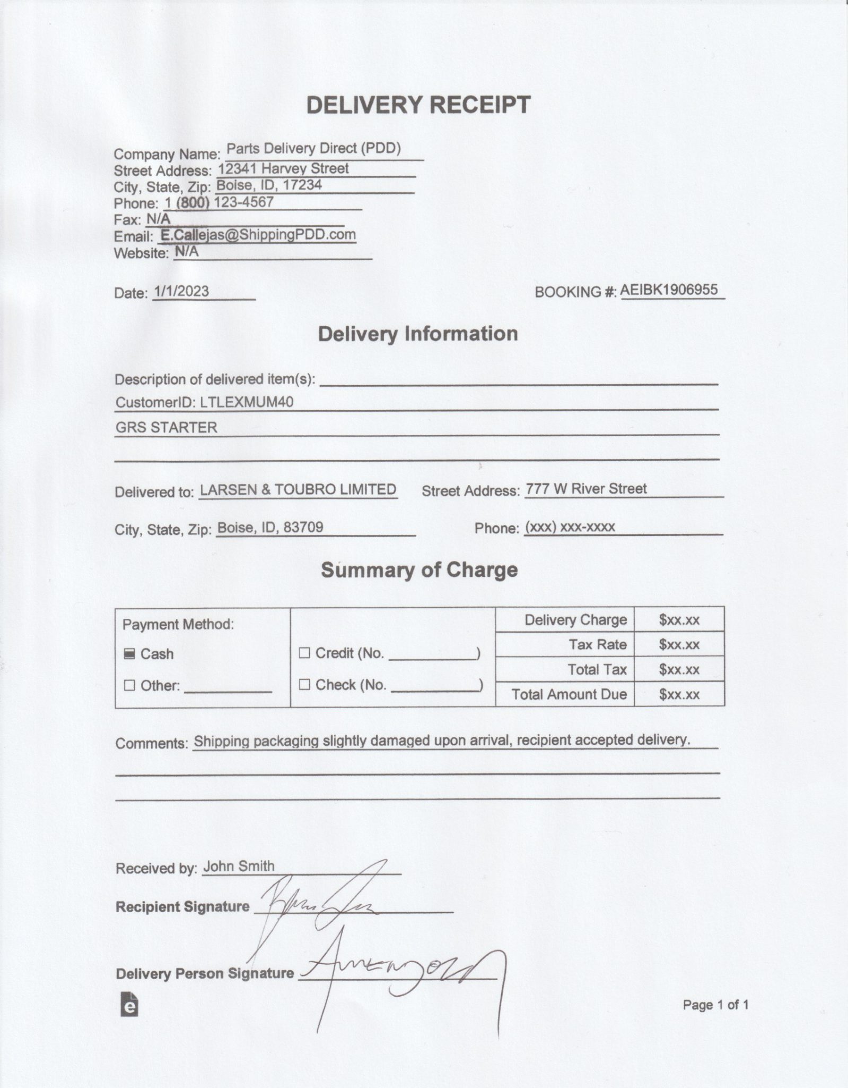

### Materials Invoice Example

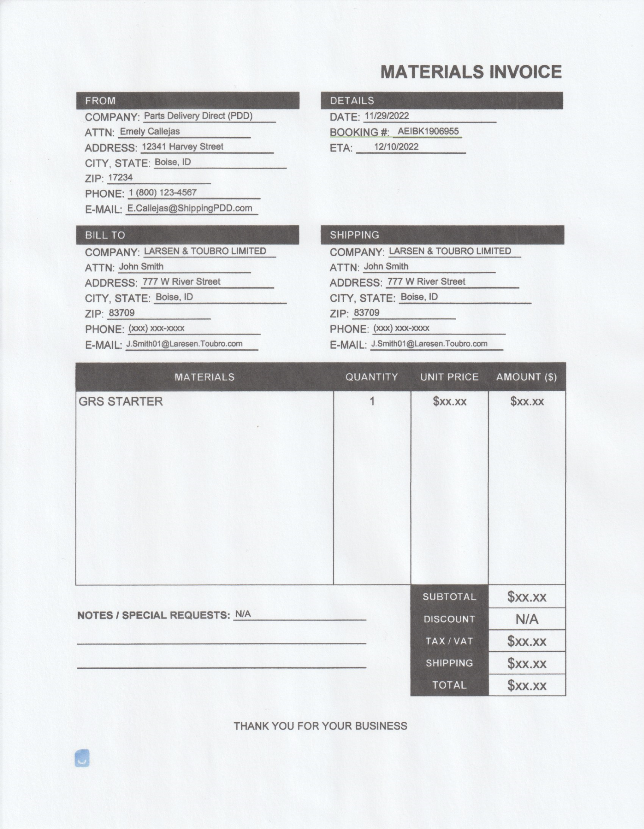

### Snapshot of Database Tables

Booking Table

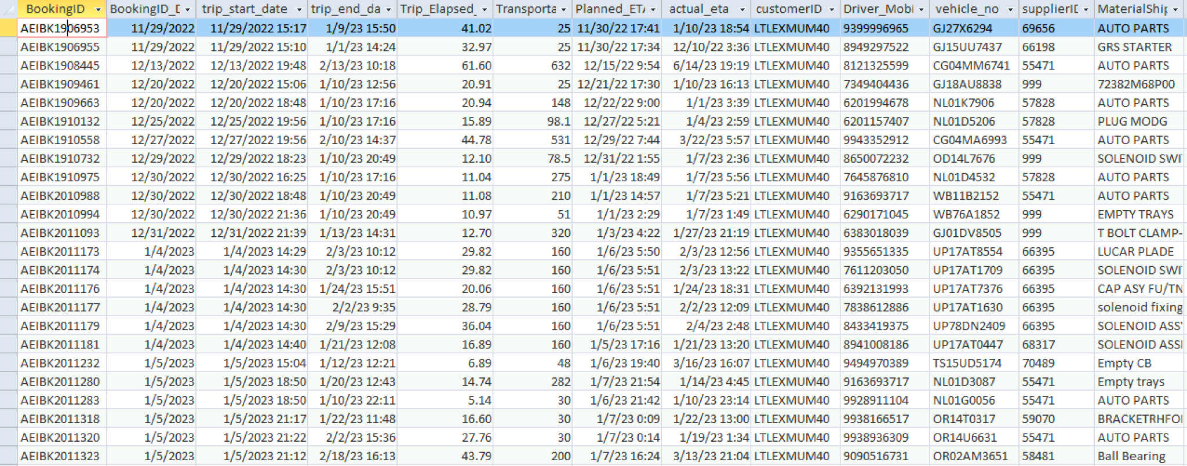

Customer Table

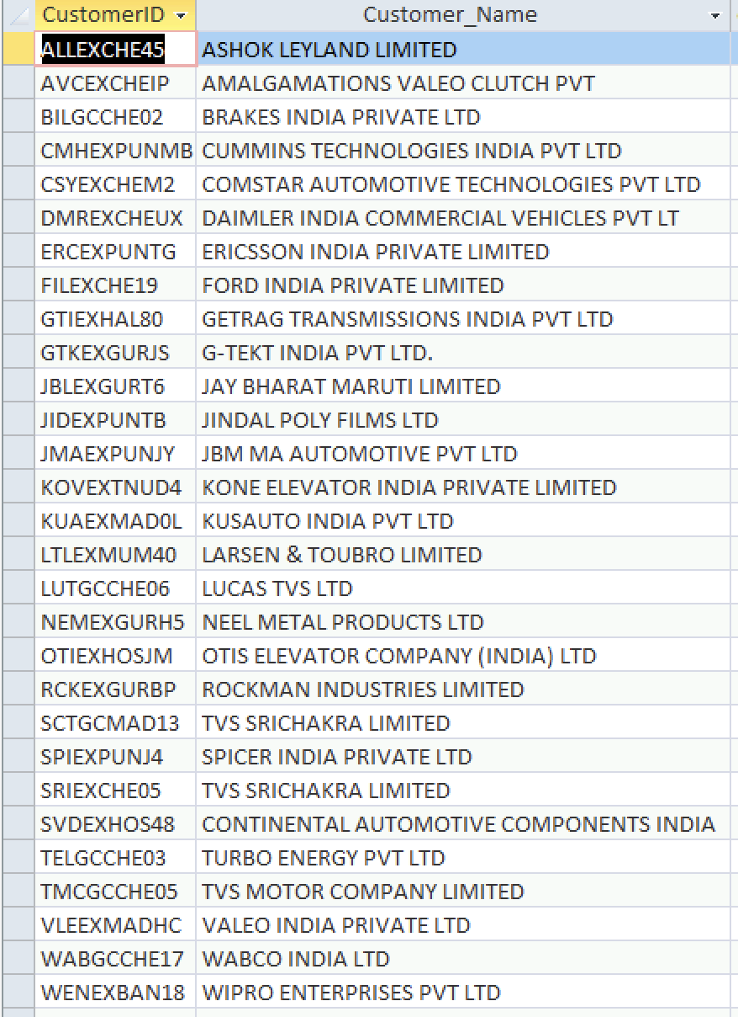

Driver Table

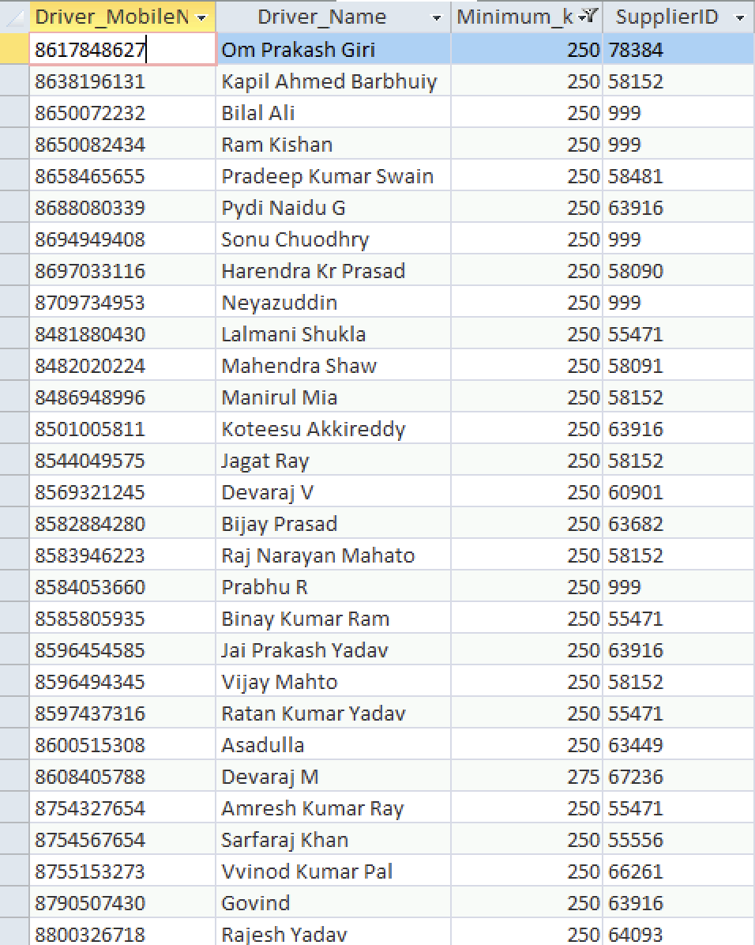

Supplier Table

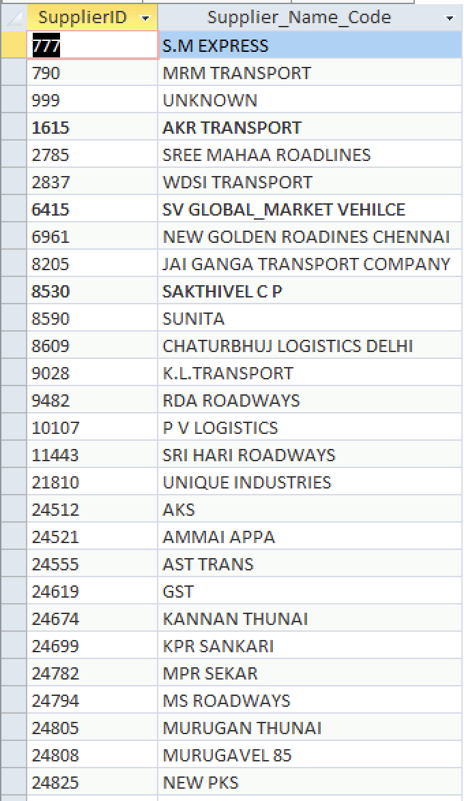

Vehicle Table

